Feminist Studies 186MP
It’s Just Entertainment:
Media and Popular Representation

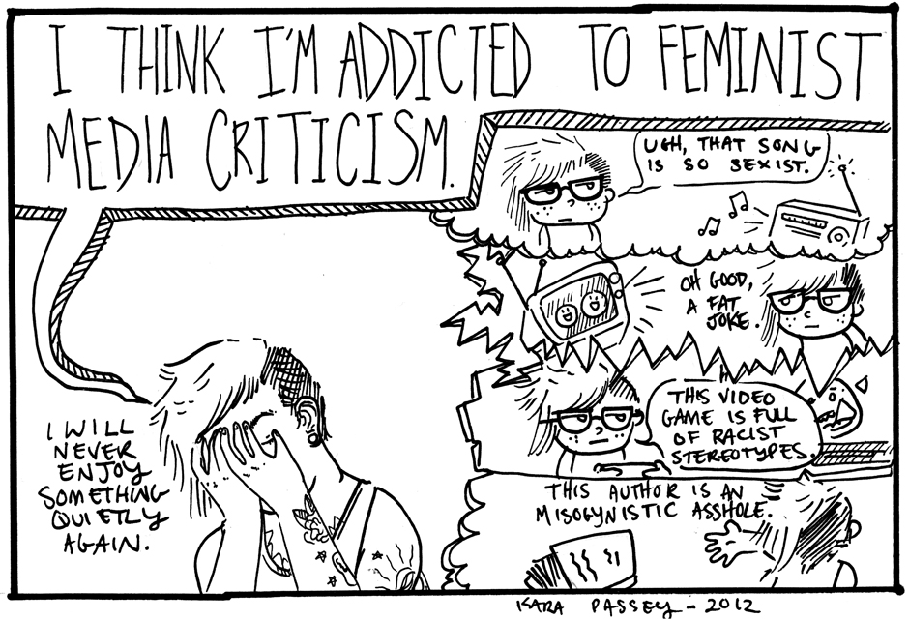

Dr. Meredith Heller
Fall 2013
Enroll Code: 66837
MW 2-3:15, LSB 1101

This special topics course explores some of the most current representations of sexuality, gender, and ethnicity in our current pop culture entertainment. How do TV shows, commercials, entertainment news programs, and social media sites mediate our understanding of what life should, or can be? How might seemingly progressive or liberal depictions of sexuality gender, and ethnicity actually maintain the status quo? In addition to scrutinizing representations of the new “normal," we explore strategies of representation for commercial gain. We also investigate how new media is challenging or resisting these stock representations. By applying critical feminist analyses to the most up-to-date media texts and practices, we will understand why our entertainment is never just entertainment.

